I did my best to bolden task you need to accomplish and the rest is context or explaining. If you have any questions ask, or I can remote in if it is too difficult. I understand this can be hard to understand.

I’m assuming by you saying you have bash that you went through the steps similar to here <http://www.pcworld.com/article/3106463/windows/how-to-get-bash-on-windows-10-with-the-anniversary-update.html> and that you search and find “Bash” by **hitting windows key and “q” (or just hitting the start button in bottom left) then type bash**. It should come up, if you’ve never launched it it might not have an icon. Just select it. It will launch.

Then you should be prompted to if you want to install it; **type “y” then enter** to continue.

It should say like “Downloading from the Windows Store… XX%”

Then **type in a UNIX username and password as prompted**, I recommend it to be short, maybe just your first name, no spaces. Remember this and the password.

You should then see some green followed by maybe blue text and a highlighting cursor.

**Type “cd” and hit enter.** If you had blue text it should go away and the line end with a money sign.

**Type “sudo apt-get update” then enter** after it’s finished

**Type “sudo apt install gcc” and hit enter then enter your password if requested**

**Type “y” when prompted then enter** it’s goanna download some stuff and unpack it

What this is is your compiler so that you can convert code into something that a computer can run in case you’re curious.

**Type “sudo apt install make”** this is something that you can easily run the program instead of complicated commands

Now you want to open up your file explorer (the folder icon) and figure out your computer username. **Go “This PC”, your “C” drive, “Users” then memorize the name (later on remember mine is “jakem” so replace mine with yours later)**. **While you’re there create a new folder named “VTOBidProgram” and paste all the files that were in the email with this besides this one. Then copy and paste an example of your bid page that looks similar how my dads looks in bids.txt but of course remove all the data that is already in there so it properly calculates your spot.** If you don’t do this and leave bids.txt as it is it won’t find your name

This is where it’s might get a little tricky. If you get stuck during the next paragraph I recommend stopping, emailing or texting me so something doesn’t mess up and require more work.

**Type “vim .bashrc”** a bunch of stuff is gonna pop up some in blue others in other color.

**Hold down your “j” key until you reach the bottom** by holding it down you should scroll down

**Hit the “l” key** and your cursor should move to the right so it is below an ‘i’

**Hit the “i” key** and “insert might appear on bottom

**Use your right arrow key to go to the right then hit enter** that should add a line to the file

**Then type “cd ./../../mnt/c/Users/jakem/VTOBidProgram” hit the escape key, and type “:wq” and press enter** this should return you to the main screen ‘UNIXUsername@...’.

This is similar to what that last file should look like, don’t worry if you are missing some things I have like the “export” lines and make sure you do “VTOBidProgram” and not “CLionProjects” like I have.

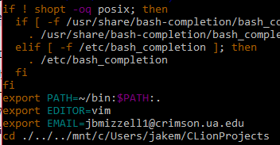

**Exit out of Bash and start it back up**

If it says something like “No file or directory found” it is probably because you messed up typing in the “cd...” stuff. Just check spelling and slashes.

**Type “make test”** if it shows something similar to this pat yourself on the back!

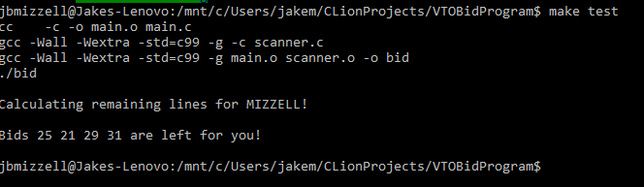

If it doesn’t have the “Bids .... are left for you!” line and instead like this

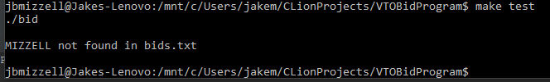

It means that in the bids.txt file you have your name doesn’t exist. If it is printing out a different name than how yours appears in the bids.txt though let me know because that’s my mistake.